ONLINE SUPPLEMENT
Supplementary Figure 1: Used Cardiac Rehabilitation Capacity by SEAR Country with Programs*
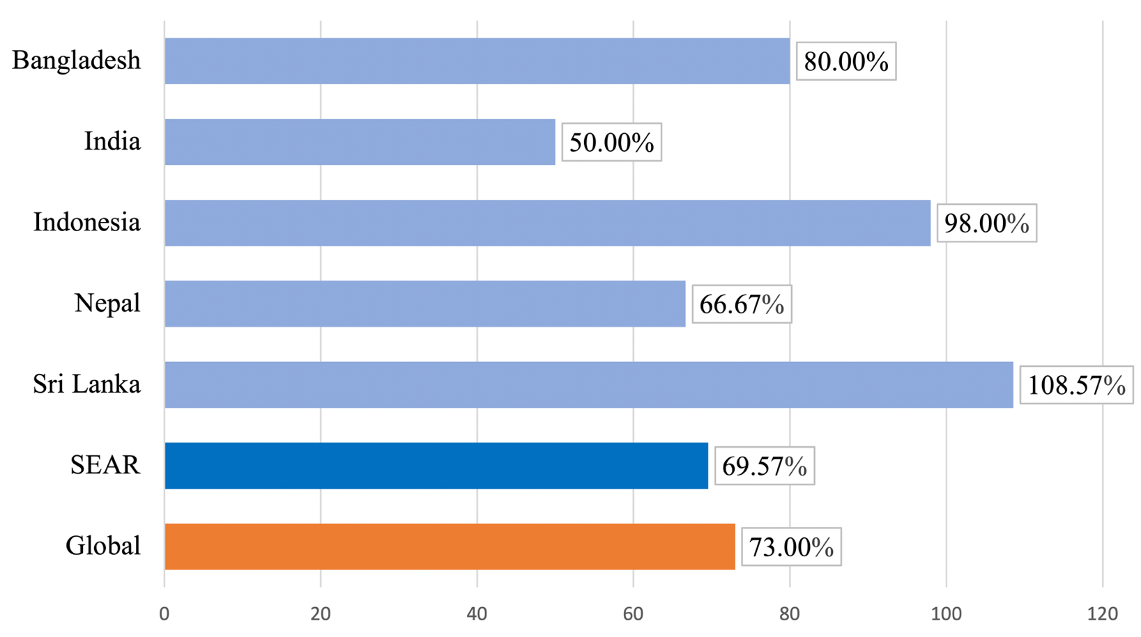
*total number of patients served per year per country (i.e., volume=median number of patients a program served multiplied by total number of programs in a country) divided by national cardiac rehabilitation capacity, which represents proportion of available spots which are not used (i.e., 100% reflects all available spots are used annually). Data from Thailand were not available.
SEAR, South-East Asia Region
Supplementary Table 1. Estimated Annual Ischemic Heart Disease Incidence (2016) in SEAR Countries without Cardiac Rehabilitation
Country | Country Income Classification | Human Development Index* | IHD Incidence | IHD Incidence/ 100,000†
Bhutan | LMIC | 0.607 | 1,319 | 165
Maldives | UMIC | 0.701 | 625 | 172
Myanmar | LMIC | 0.556 | 108,283 | 199
North Korea | LIC | NA | 48,117 | 182
Timor-Leste | LMIC | 0.605 | 1,695 | 146
IHD, ischemic heart disease; LMIC, lower-middle income country; UMIC, upper-middle income country; LIC, low-income country; NA, not available; SEAR, South-East Asia Region
*from United Nations Development Program (Jahan S. Human Development Report 2016 Human Development for Everyone. New York; 2016, http://hdr.undp.org/sites/default/files/2016_human_development_report.pdf)
†obtained from Global Burden of Disease study (University of Washington, Institute for Health Metrics and Evaluation (IHME). Global Burden of Disease Results [Internet]. Seattle, WA: IHME, 2016. http://ghdx.healthdata.org/gbd-results-tool, (accessed 6 December 2017)

Supplementary Table 2: CR Funding Source and Cost to Program to Serve 1 Patient by SEAR Country with CR
Country | Funding Source  n (%) |  |  | Cost to Serve 1 Patientfor a Complete Program  (PPP2016)
 | Public | Private | MultipleSources
Bangladesh | 0 | 1 (100.0%) | 0 | 336.38
India | 1 (5.6%) | 16 (88.9%) | 1 (5.6%) | 1,027.12±2,030.27†
Indonesia | 5 (55.6%) | 0 | 4 (44.4%) | 276.05±14.21†
Sri Lanka | 1 (100%) | 0 | 0 | -
Nepal | 1 (100%) | 0 | 0 | -
SEAR Total | 8 (26.7%) | 17 (56.7%) | 5 (16.7%) | 844.38±1,762.77†
SEAR Median  (Q25-Q75) |  |  |  | 284.80  (194.08-722.91)
Global | 584 (56.5%)* | 185 (17.9%)* | 264 (25.6%) | 1549.42±1,666.01†
Global  Median  (Q25-Q75) |  |  |  | 976.25  (486.89-1956.04)*
SEAR, South-East Asia Region; CR, cardiac rehabilitation; PPP, Purchasing Power Parity (http://eppi.ioe.ac.uk/costconversion/default.aspx)
†mean ± standard deviation for a complete program. PPP is equivalent to 2016 $USD
USD, United States Dollars
- response about CR cost was not provided by any respondent in the country
*significant difference (P<.05) between SEAR and global using Chi-Square testor the Mann-Whitney U test as applicable
Note: Due to missing data, percentages are computed where the denominator is the number of valid responses from responding programs

Supplementary Table 3: Most Common Cardiac Rehabilitation Indications Accepted by SEAR Country with Programs, and Versus Other Countries

Country (n) | CABG | Post-Myocardial infarction / acute coronary syndrome | Percutaneous coronary intervention | Heart failure | Stable coronary artery disease | Rheumatic heart disease
Bangladesh (n=1) | 1 (100.0%) | 1 (100.0%) | 0 (0.0%) | 1 (100.0%) | 0 (0.0%) | 1 (100.0%)
India (n=18) | 13 (100.0%) | 13 (100.0%) | 10 (76.9%) | 11 (84.6%) | 10 (76.9%) | 6 (46.2%)
Indonesia (n=10) | 8 (100.0%) | 8 (100.0%) | 8 (100.0%) | 8 (100.0%) | 6 (75.0%) | 2 (25.0%)
Nepal (n=1) | 1 (100.0%) | 1 (100.0%) | 1 (100.0%) | 1 (100.0%) | 1 (100.0%) | 1 (100.0%)
Sri Lanka (n=2) | 2 (100.0%) | 2 (100.0%) | 2 (100.0%) | 1 (50.0%) | 2 (100.0%) | 1 (50.0%)
SEAR Total (n=32) | 25 (100.0%) | 24 (96.0%) | 21 (84.0%) | 22 (88.8%) | 19 (76.0%) | 11 (44.0%)
Global  (N=1050) | 792 (95.7%) | 809 (97.5%) | 799 (96.5%)* | 735 (88.8%) | 673 (81.3%) | 424 (51.2%)
CABG, coronary artery bypass graft; HF, heart failure; PCI, percutaneous coronary intervention; SEAR, South-East Asia Region
*significant difference (P=.013) between SEAR and global programs for PCI indication using Fisher’s Exact test
Note: Due to missing data, percentages are computed where the denominator is the number of valid responses from responding programs.
Supplementary Table 4. Non-Cardiac Indications Served in Cardiac Rehabilitation Programs in SEAR
Country (n) | High-Risk / Primary Prevention | Diabetes | Chronic Lung Disease | Intermittent Claudication/ Peripheral Vascular Disease | Stroke / Transient Ischemic Attack | Cancer
Bangladesh (n=1) | 1 (100.0%) | 1 (100.0%) | 1 (100.0%) | 1 (100.0%) | 1 (100.0%) | 1 (100.0%)
India (n=18) | 11 (84.6%) | 9 (69.2%) | 8 (61.5%) | 8 (61.5%) | 5 (38.5%) | 7 (53.8%)
Indonesia (n=10) | 3 (37.5%) | 3 (37.5%) | 1 (12.5%) | 4 (50.0%) | 1 (12.5%) | 0 (0.0%)
Nepal (n=1) | 1 (100.0%) | 1 (100.0%) | 0 (0.0%) | 0 (0.0%) | 0 (0.0%) | 0 (0.0%)
Sri Lanka (n=2) | 2 (100.0%) | 1 (50.0%) | 1 (50.0%) | 0 (0.0%) | 0 (0.0%) | 0 (0.0%)
SEAR Total (n=32) | 18 (72.0%) | 15 (60.0%) | 10 (40.0%) | 12 (48.0%) | 7 (28.0%) | 7 (28.0%)
Global†  (N=1050) | 475 (57.4%) | 406 (49.0%) | 330 (39.9%) | 411 (49.6%) | 248 (30.0%) | 156 (18.8%)
SEAR, South-East Asia Region
†no significant difference between SEAR and the other countries (i.e., global) in serving of any non-cardiac indications (using Fisher’s Exact Test for cancer and Chi-Square test for all other indications)
Note: Due to missing data, percentages are computed where the denominator is the number of valid responses from responding programs
Supplementary Table 5. Risk Factors Assessed in Cardiac Rehabilitation Programs by SEAR Country
 | Blood Pressure | Adiposity | Tobacco Use | Lipids | Glucose/ HbA1c | Physical Inactivity | Poor Diet | Depression | Total†
Bangladesh (n=1) | 1 (100.0%) | 1 (100.0%) | 1 (100.0%) | 1 (100.0%) | 1 (100.0%) | 1 (100.0%) | 1 (100.0%) | 1 (100.0%) | 8.0
India (n=18) | 15 (100.0%) | 15 (100.0%) | 14 (93.3%) | 15 (100.0%) | 13 (100.0%) | 14 (93.3%) | 11 (78.6%) | 12 (80.0%) | 7.5±0.8
Indonesia (n=10) | 10 (100.0%) | 10 (100.0%) | 10 (100·0%) | 9 (90.0%) | 9 (90.0%) | 8 (80.0%) | 7 (70.0%) | 4 (40.0%) | 6.4±1.3
Nepal (n=1) | 1 (100.0%) | 1 (100.0%) | 1 (100.0%) | 1 (100.0%) | 1 (100.0%) | 0 (0.0%) | 1 (100.0%) | 0 (0.0%) | 7.0
Sri Lanka (n=2) | 2 (100.0%) | 2 (100.0%) | 2 (100.0%) | 2 (100.0%) | 2 (100.0%) | 1 (50.0%) | 1 (50.0%) | 2 (100.0%) | 7.0±1.4
SEAR Total (n=32) | 29 (100.0%) | 29 (100.0%) | 28 (96.6%) | 28 (96.6%) | 26 (96.3%) | 24 (82.8%) | 21 (75.0%) | 19 (65.5%) | 7.0±1.1
Global* (n=1050) | 928 (99.1%) | 900 (95.8%) | 919 (98.0%) | 856 (91.3%) | 813 (88.6%) | 879 (94.3%)* | 840 (90.1%)* | 797 (85.8%)* | 7.2±1.3

SEAR: South-East Asia Region
*significant difference between SEAR and the other countries (i.e., global) in assessment of physical inactivity (P=0.021), poor diet (P=0.015),and depression (P=0.004) using Fisher’s Exact Test.
†mean ± standard deviation for total number of risk factors assessed in the country, region or globally (out of 8).
Note: Due to missing data, percentages are computed where the denominator is the number of valid responses from responding programs.

Supplementary Table 6: Cardiac Rehabilitation Dose by SEAR Country and Versus other Countries

 | Bangladesh  n=1 | India  n=13 | Indonesia  n=5 | Nepal  n=1 | Sri Lanka  n=2 | SEAR  (n=21) | Global  (N=731) | P Value*
Duration  (weeks) | 1.0 | 7.5±5.7 | 5.7±2.1 | 6.0 | 20.0 | 7.7±6.8 | 10.9±9.5 | .007*
Frequency  (sessions / week) | 3.0 | 3.9±2.9 | 2.5±0.8 | 6.0 | 0.6±0.5 | 3.3±2.4 | 3.7±5.5 | .32
Dose  (# weeks x  sessions/week) | 3.0 | 24.8±14.2 | 12.4±2.2 | 36.0 | 8.0 | 20.0±13.6 | 28.7±27.6 | .05
Intensity  (minutes / session) | 60.0 | 52.7±7.3 | 48.9±10.6 | NA | 50.0±14.1 | 51.4±8.9 | 58.6±18.6 | .01*
Total CR  hours  (Dose x intensity/60) | 3.0 | 21.9±13.5 | 10.4±3.9 | NA | 6.7±1.9 | 16.8±12.6 | 36.2±53.3 | .01*
SEAR, South-East Asia Region; NA, not available; CR, cardiac rehabilitation
*tested for difference between SEAR and other countries by Wilcoxon-Mann-Whitney
Note: mean ± standard deviation shown.

