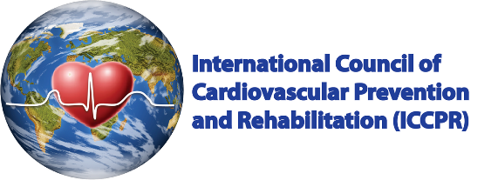
PATIENT PRE-DISCHARGE CONTRACT: CARDIOVASCULAR REHABILITATION
Medical guidelines recommend that people who have been hospitalized for a health problem such as yours should attend cardiovascular rehabilitation. Attending will help ensure the best possible recovery for you.

- I understand that it is important to attend a cardiovascular rehabilitation program. By attending this program, I can:
    - Get answers to questions that I and my family have about my recovery and health
    - Reduce my symptoms
    - Increase my energy and vitality
    - Prevent further health problems
- Yes, I understand the benefits of a cardiovascular rehabilitation program
- My healthcare provider has reviewed what cardiovascular rehabilitation programs offer, and what the benefits are for me:
  - Yes
- My healthcare provider discussed any concerns I may have about attending cardiovascular rehabilitation:
  - Yes
- My healthcare provider has referred me to a cardiovascular rehabilitation program:
  - Yes No (why not? _________________________________________)
I know that there is a cardiovascular rehabilitation program at [LOCATION]. The specialist team will be on hand to give me advice and information to help me make informed choices about my rehabilitation:
  - Yes
- If I don’t live close to the cardiovascular rehabilitation program, I know the rehabilitation program will be calling me to refer me to a program closer to my home in the next week or about the potential to participate in a home-based program.
- If I don’t hear from the cardiovascular rehabilitation program to book me in within the next 14 days or if I have any questions, I will not hesitate to contact them at [CONTACT INFO]
  - Yes

Patient Signature | Date
Healthcare Provider Signature | Date

For more information on Cardiac Rehabilitation, please visit:
https://www.aacvpr.org/Cardiac-Patient-Resources

